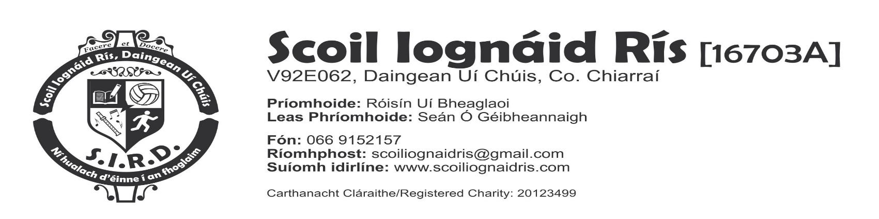

Liosta Leabhair 2022/2023 - Rang a 3

Gaeilge: Seo Leat 4 (Folens) (le fáil ar cíos ón scoil /rented from school)
Fuaimeanna agus Focail 3 Folens
Mo Leabhar Gramadaí Rang a 3 (Educate.ie)
Béarla: Ready to Go (C.J Fallon) (le fáil ar cíos ón scoil /rented from school)
Shared Reading/Novels (le fáil ar cíos ón scoil/rented from school)
Jolly Phonics Grammar 3
English in Practice New wave 3 Prim Ed
Dictionary
Mata: Gafa le Mata 3- (C J Fallon) (le fáil ar cíos ón scoil /rented from school)
Mata Meabhrach 3 C.O.G.G
Leabhar Tablaí
Seaimpín na dTáblaí Rang 3
Peannaireacht: Ag Ceangal Liom D Lámhchúnta.com(acu ó anuraidh-coimeádta ar scoil)
O.S.I.E.: Féach Thart (le fáil ar cíos ón scoil/ rented from school)
Teagasc Criostaí: I nGrá Dé Rang 2 (VERITAS)
Ceol: Feadóg Stáin – (Gléas D)

Cóipleabhair:
3 Chóipleabhair Mata – 3 Maths Copies | 40 Page Display Book/Folder  Leabhar le 40 leathanach
7 Chóipleabhair le línte (80 lth.)  7 Lined Copies (80 pages)  1 Leabhair Nótaí do scrudú litriú –  1 Note Book for spelling tests  1 Leabhar Gearrthóg A3 - 1 Scrapbook A3 | Rialóir - Ruler, Pinn luaidhe - Pencils,  Pinn luaidhe daite/marcóirí –Coloured Pencils/Twistables  Peann dearg- Red Pen  Scriosán – Rubber, Biorthóir – Parer  Gliú- Pritt stick glue  Siosúr-Scissors

€61 for photocopying, book rental, books purchased Art & Crafts Materials and miscellaneous items
€9 Personal Accidental Insurance TOTAL: €70.00

Le do thoil cuir ainm an dalta ar a chuid éadaigh, leabhra, pinn luaidhe, scríosán……etc.
Please put your child’s name on all clothing, books, pencils, rubbers….etc

